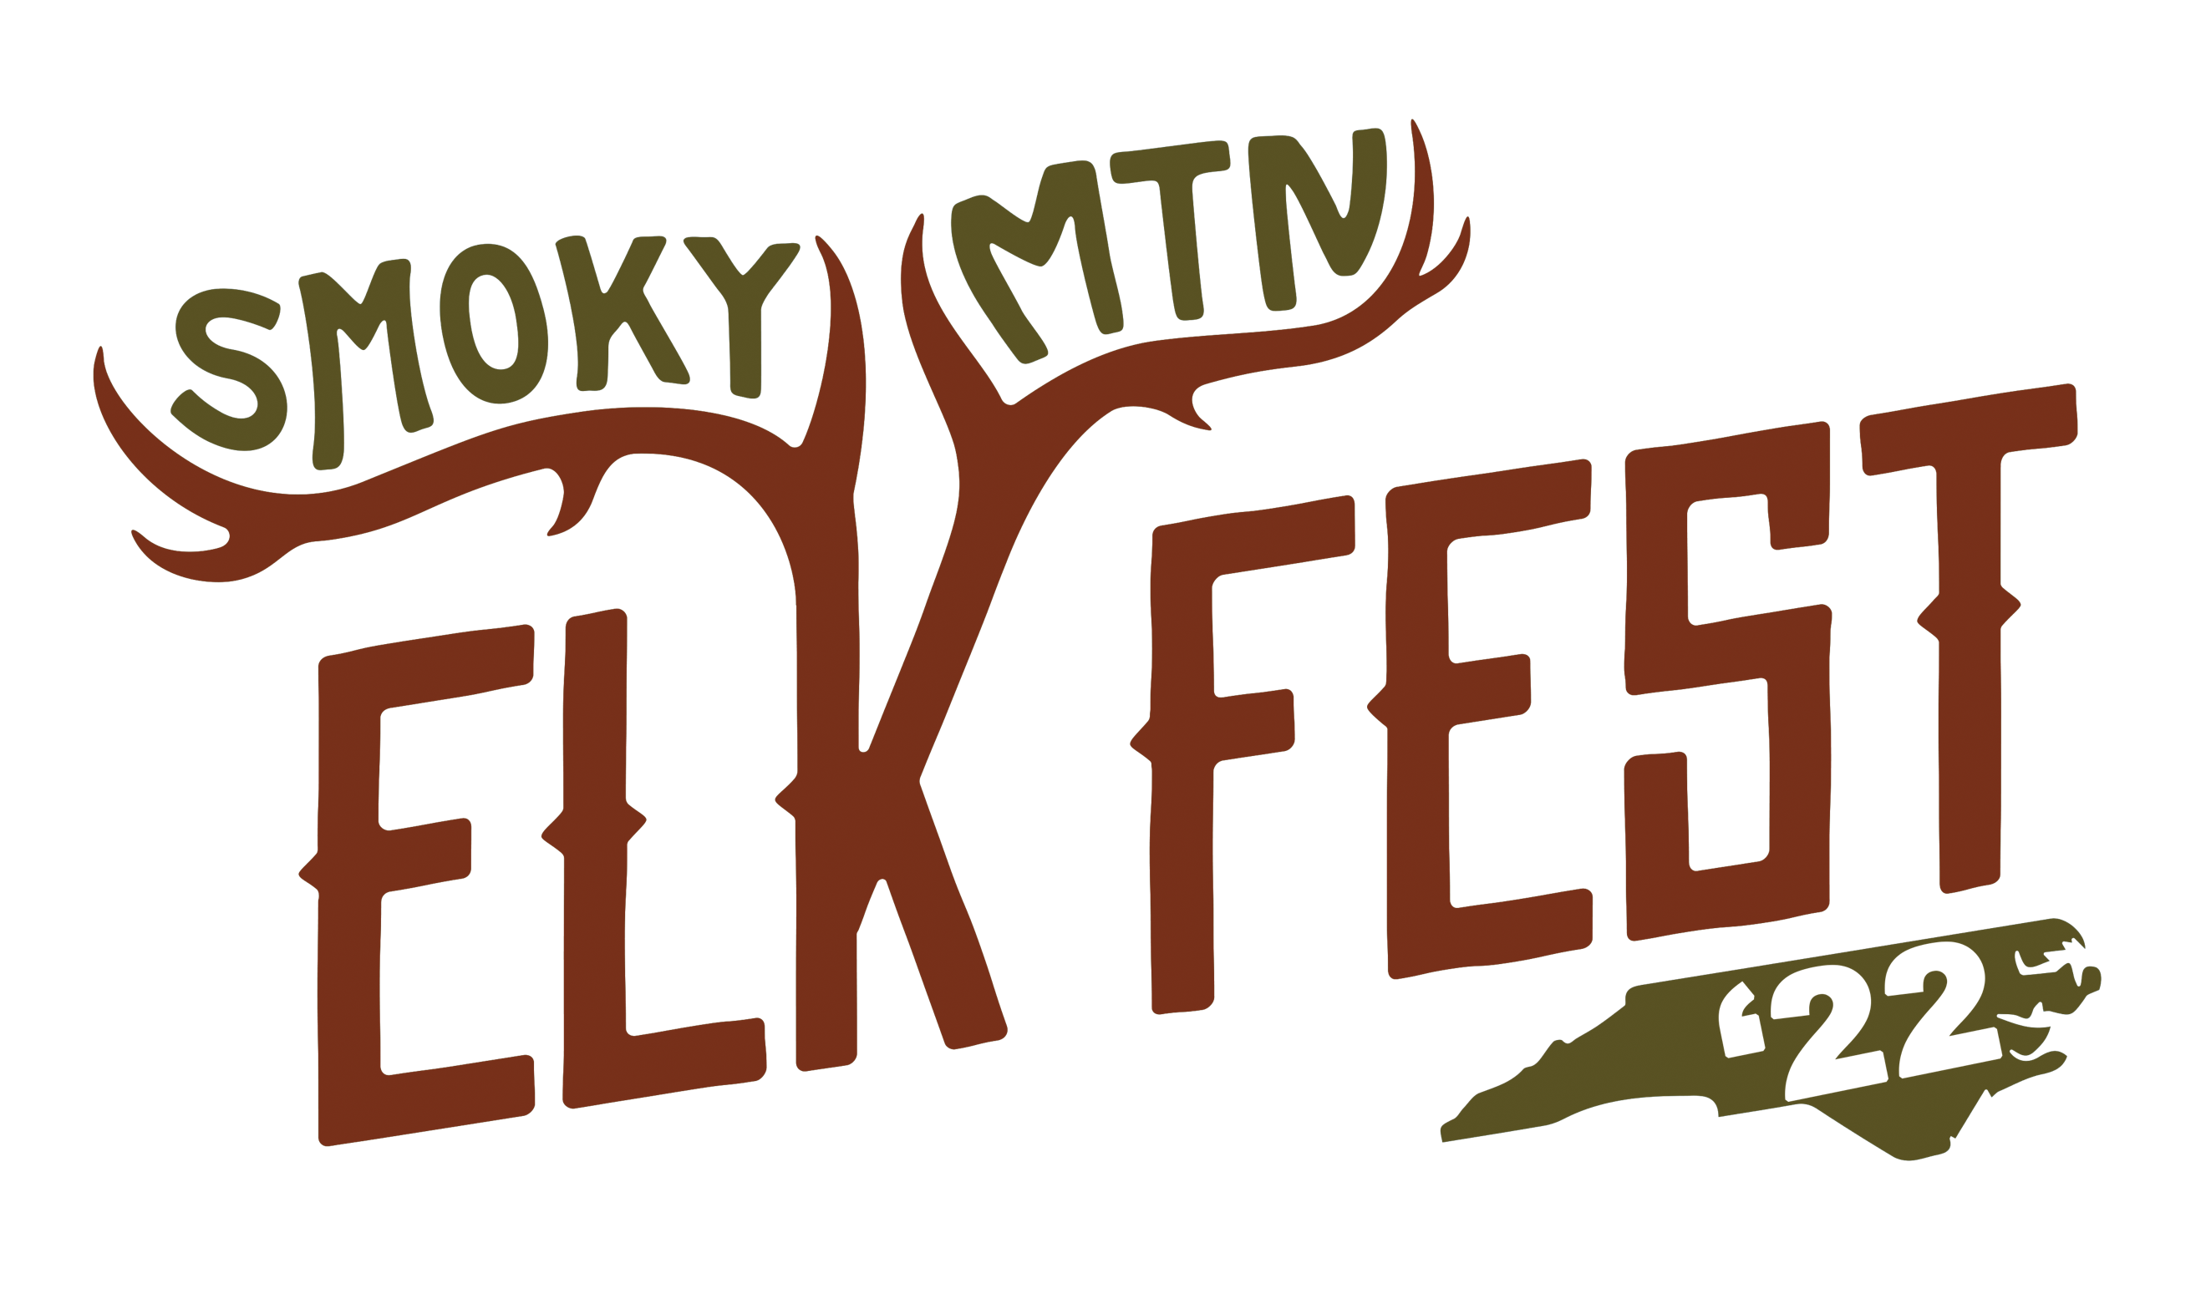

Vendor Rules Agreement

This agreement is entered into by and between Smoky Mountain Elk Fest (Haywood County TDA), herein after referred to as Elk Fest, and the VENDOR listed below, in consideration of the mutual promises and covenants hereinafter contained, it is hereby agreed as follows:

FESTIVAL DATES & HOURS:
Friday September 30, 2022, from 10:00AM – 6:00PM
Saturday October 1, 2022, from 9:00AM – 6:00PM

SCOPE OF WORK:
VENDOR agrees to perform services under this Agreement primarily by serving as a merchandise, food, service, demonstrator, or information vendor at Elk Fest to be held at the Maggie Valley Festival Grounds, Maggie Valley, NC.

VENDOR LOADING IN AND OUT:
Load In: Thursday, September 29, 2022, Noon – 6:00pm
Friday, September 30, 2022, 7:00am – 9:00am (No entrance for setup after 8:30AM)
Load Out: Saturday, October 1, 2020, 6:00pm – 8:00pm (cannot bring vehicle into space until after 6:00pm.) You may bring vehicle up to gate to load.

This is a rain or shine event; we DO NOT LEAVE or PACK UP if it rains.

VENDOR RESPONSIBILITIES:
Each vendor is responsible for their booth area. You must leave your booth area clean upon departure. All vendors are required to dispose of their own trash, waste and products in the approved dumpsters. Vendors are responsible for any damages occurred on or in the assigned booth space area (grease, food, or other damage). The Town of Maggie Valley has dumpsters on site which are to be used.

Should the Town of Maggie Valley need to make any repairs to your area,
you will be responsible for payment of their services.

FOOD VENDORS:
All food vendors must fill out the required application for temporary food establishments with the Haywood County Environmental Health Department. Payment and application must be in their office at least fifteen (15) days prior to the event. You can access the permit at: https://www.haywoodcountync.gov/443/Temporary-Food-Establishments. All food items must be listed, or a menu attached. The application along with a sample layout and rules will be mailed or emailed to you after we have received your application and payment along with this signed agreement. Any further questions contact Garron Bradish – 828-452-6620; EMAIL garron.bradish@haywoodcountync.gov

Absolutely NO liquids of any kind will be poured, spilled or disposed of on the festival grounds. There will be a designated container for disposing of grease.
Do not put grease in trash cans.

INDEMNIFICATION:
VENDOR indemnifies and holds harmless Smoky Mountain Elk Fest (Haywood County TDA), it’s sponsors, the Town of Maggie Valley, their officials, representatives, offices, agents, employees from and shall process and defend at its sole expense, any and all claims, injuries, demands, damages, suits at law or at equity, liabilities, losses, judgements, liens, expenses and costs arising out of acts and/or omissions by VENDOR, it employees, agents, representatives of volunteers relative to any activity and/or services covered hereunder. In the event of recovery due to the aforementioned circumstances, VENDOR shall pay any judgement or lien arising therefrom, including any and all costs as part thereof.

The VENDOR agrees to abide by the rules and directions of the event staff. Space assignments are subject to change. Exclusivity is not implied or granted. This constitutes the complete and final agreement of the parties. It replaces and supersedes all oral and written proposals and agreements heretofore made on the subject matter and may be modified only in writing and signed by both parties, both acknowledge receipt of an executed copy of the agreement. VENDOR must sign and return this agreement with the full booth fee (if applicable).

My signature below certifies that I have read, understand, and agree to comply with the terms of this Agreement.

Business Name: _________________________________________ Date: ________________

Printed Name of VENDOR/Owner: _________________________________________________

Signature of VENDOR/Owner: _____________________________________________________

